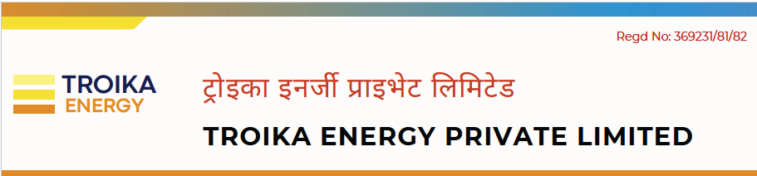
Date: July 29, 2026
To,
The Host Master
Mercantile Communication Pvt. Ltd.,
Durbar Marg, Kathmandu, Nepal
Subject: Request for registration of .com.np domain – troikaenergy.com.np
Dear Sir/Madam,
I am writing to formally request the registration of the domain name troikaenergy.com.np under the name of our registered organization, Troika Energy Private Limited Company.
We will be using this domain name to establish an official online presence for our business operations, branding, and customer communication in Nepal. Along with this letter, I have attached the required supporting documents for your verification a copy of the Company Registration Certificate (OCR).
We confirm that all information provided during the online application process is accurate and matches the official documentation attached. We request you to kindly approve the domain registration at your earliest convenience. Thank you for your time and consideration.
Yours Sincerely,

Kadam Mani Nepal
Address: Kathmandu-11, Trade Tower, Nepal
Contact: +977-9869556604
Email: info.troikaenergy@gmail.com


